Ideation Phase
Empathize & Discover

Date | 05 July 2026
Team ID | Solo Project – Individual Capstone
Project Name | Smart Library Request Workflow(Service Now)
Maximum Marks | 4 Marks

Smart Library Request Work — Empathy Map:
1.Student (Primary User)
The map below captures the behaviours, attitudes, and pain points of the student — the primary user of the Library Management System — based on observation of the current manual book-borrowing process.

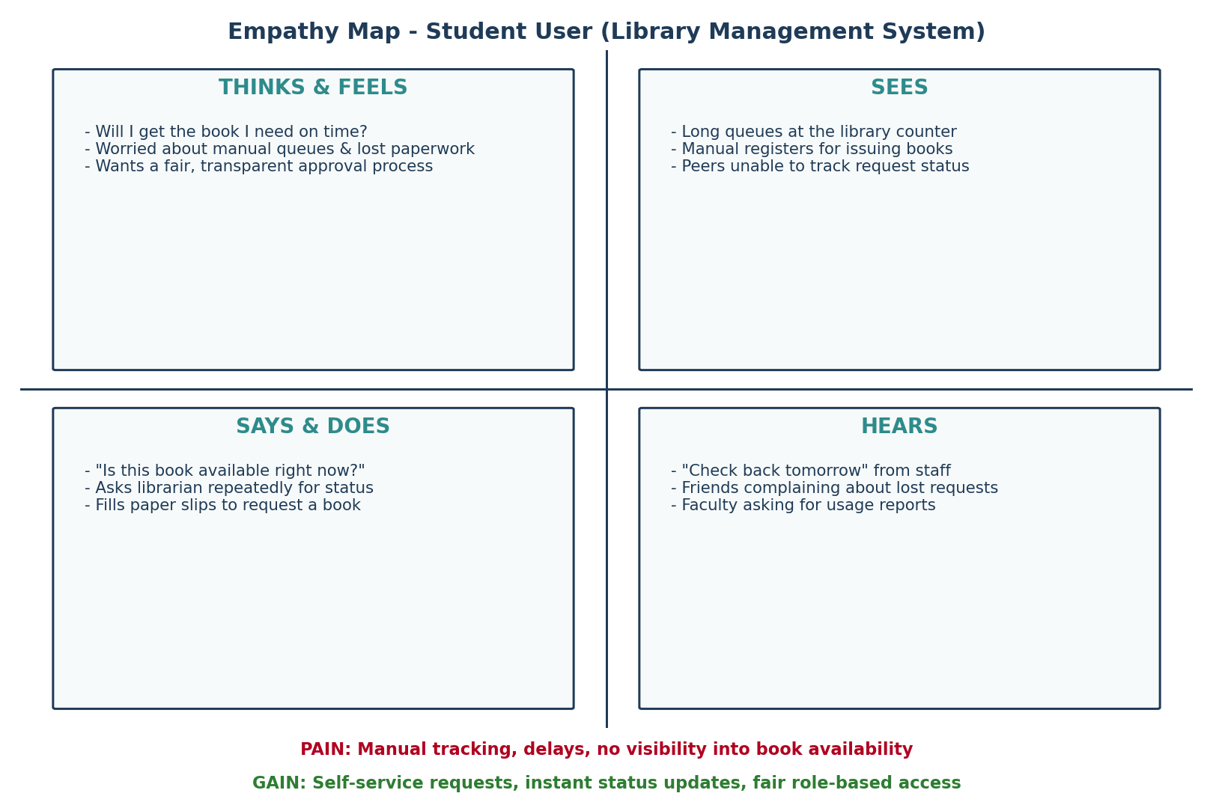

2. Librarian (Secondary User)
Quadrant | Observation
Says & Does | Cross-checks paper registers by hand; manually updates a book's status after every issue or return.
Thinks & Feels | Wants fewer manual errors and a fast way to see which books are in demand.
Sees | Piles of pending request slips; students repeatedly asking for status updates at the counter.
Hears | Requests from faculty for usage reports; complaints about slow turnaround on approvals.
Pain | No single source of truth for book status; compiling reports takes hours of manual counting.
Gain | Automated approvals, accurate real-time book status, and a ready-made “Most Borrowed Books” report.

